

**A Glimpse through the 3-Day Mud Building Block Workshop**

Our 6th graders participated in a 3-day Mud Building Blockworkshop with Smt. Meenakshi Umesh from Puvidham. In this blog, let’s look at how the 3-day mud construction workshop unfolded from the perspectives of our 6th grade children.

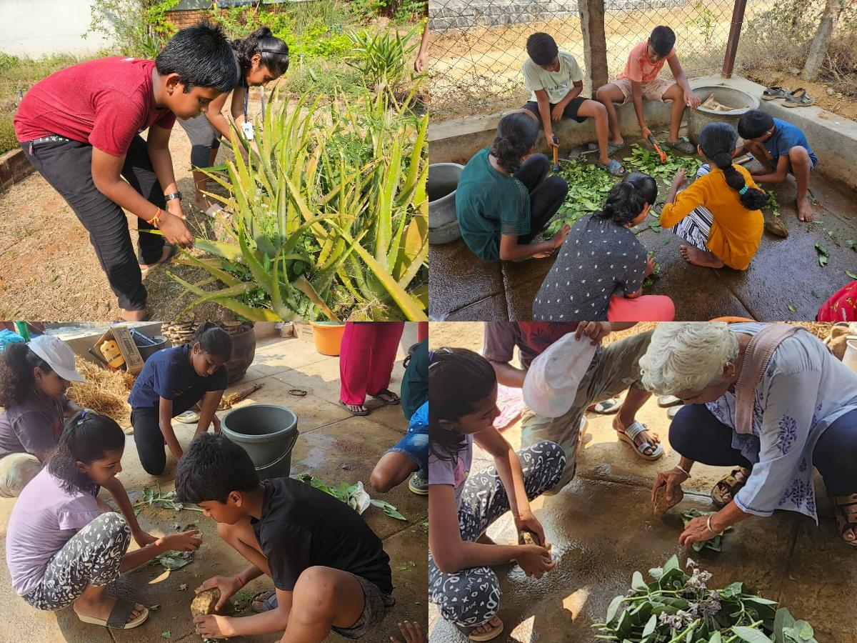

In Tagore Hall to meet our mentor, Ms. Meenakshi Mam. Ms. Meenakshi mam challenged us with the question of why we shifted to cement despite the known benefits of mud.

[Click here for read more……..](https://www.agastyaacademy.edu.in/post/a-journey-through-3-day-mud-building-block-workshop)